Accessory specifications

# E-Ink Specifications

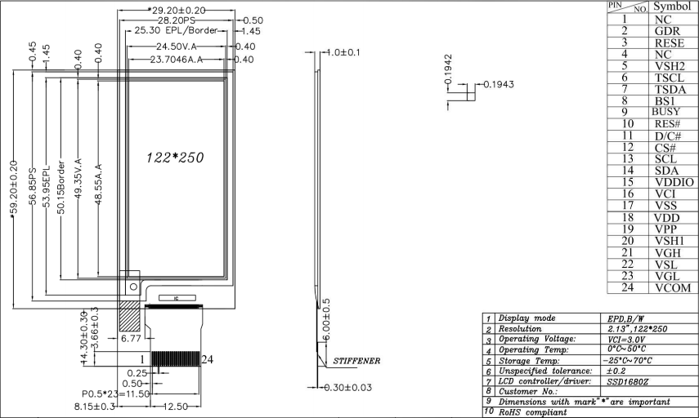

# 2000mAH Lithium Battery Specifications

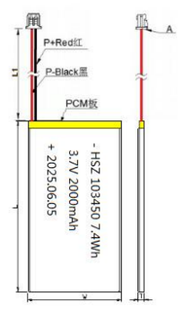

|  |  |
| --- | --- |
| **Project** | **Standard** |
| Battery length | L≤52.5mm |
| Battery width | W≤34.5mm |
| Battery thickness | T≤10.3mm |
| Wire length | L1:60±5mm |
| Wire specification | 1571 26#Line |
| Plug size | 1.25-2P |
| Connecting Wires:  Red: connect to “+”;  Black : connect to ground “—” | |